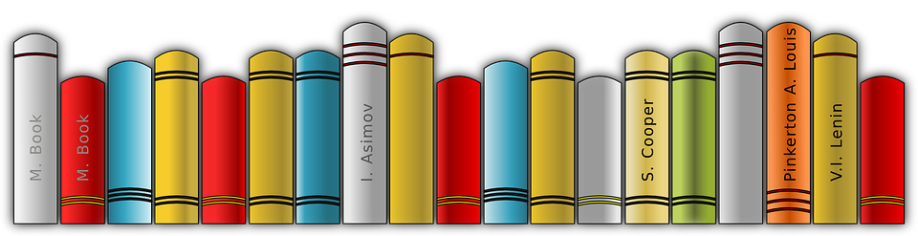
GIGANTIC BOOK SALE!
Friends of the New Bern-Craven County Public Library

FREQUENTLY ASKED QUESTIONS ABOUT THE SALE
Q. Where is the sale being held?
A. St. Paul Catholic Church Family Life Center, 3005 Country Club Rd., New Bern
The Family Life Center is behind the church.
Q. What are the dates and times of sale?
A. Friday August 6th 9 AM to 5 PM, Saturday August 7th 9 AM to 5 PM, Sunday August 8th
12:30 PM to 4:30 PM.
Q. Will there be a members’ only preview night?
A. Yes! Members who are current on their dues and public library staff will be allowed to
purchase as many books as they want on Thursday 8/5 from 4 PM to 7 PM. We’ll even
throw in some refreshments! You can pay or renew your membership at the door.
Q. Any other special deals?
A. Yes! On Sunday we will have our usual “fill up a paper grocery bag for $5” deal. We’ll
supply the bag. We also invite teachers, members of nonprofit organizations, faith-based organizations, and Little Free Library Stewards who will use the books for charitable purposes to come on Sunday between 2 PM and 4 :30 PM and take as many books as they can use—FREE. Just tell us who you are representing and how you intend to use the books.
Q. What’s different this year?
A. Well, we have twice as many books for sale than normal due to COVID. The selection
has never been better! Hardback books will be $3 each, trade paperback will be $2 each and small paperbacks will be $1 each. Children’s soft cover books and small chapter books with soft covers will be 50 cents each with buy two/get one free. Children’s hardcover books will be $1. We will not be handling coins this year either as payment or as change. No bills larger than $20. We will be able to take a check. We are also set up this year to take credit cards ($5 minimum).
Q. Where should I take books that I want to donate for the sale?
A. We ask that you bring them to the Family Life Center preferably during the days and
times we are setting up, but you can bring them to the sale.
Q. Do you need any help?
A. You know we do! To volunteer contact Ann Niethamer ann.niethamer@gmail.com
Cell: 252.626.2485. We need people to:
- Help us get the word out! Email your friends, family and co-workers. Make copies of the flyer and post them in your neighborhood, at stores, on bulletin boards, etc. Get it posted on websites and social media. If you are not able to do anything else, at least do this, please. Click here to access the flyers.
- Load, off-load and transport books (Mon. 8/2 8 AM to 3 PM and possibly Tue. 8 AM to 12 PM) Involves: lifting and carrying boxes of books, using hand trucks and dollies. Meet at the River Mills storage unit 2723 Neuse Blvd. in rear.
- Help setting up (Mon 8/2 9 AM to 3 PM, Tue 8/3 8 AM to 3 PM, Wed 8/4 9 AM to 12 PM) Involves: setting up tables, setting up signs, organizing categories of books, moving and lifting boxes of books, taking books out of boxes and organizing them on the tables. St. Paul Catholic Church Family Life Center.
- Help at the Members’ Only Preview Sale (Thu. 8/5 4 PM to 7 PM) Involves:
buying or making refreshments, serving refreshments, checking members off the list, taking membership applications, keeping book tables straightened, taking payments for purchases, assisting customers.
- Help at the sale (Friday August 6th 9 AM to 5 PM, Saturday August 7th 9 AM to 5 PM, Sunday August 8th 12:30 PM to 4:30 PM) Involves: keeping book tables straightened, taking payments for purchases, customer assistance.
- Help taking down the sale (Mon 8/9 8 AM to 3 PM, Tue 8/10 8 AM to 12 PM) Involves: sorting books to keep and books to be discarded, boxing up books, breaking down empty boxes, taking down and returning tables and chairs to storage area, moving boxes of books and general cleanup.
Q. Is there any benefit to me for helping?
A. We hope you’ll offer to help because you know how overworked the Friends’ Board
members are! But there is a benefit: those members who help can take the
equivalent of one hard cover book for every hour worked. And you get to cherry-pick
your books if you help set up! What’s not to love! Contact Ann today to sign up!
And of course, please buy your share! We have a huge number of books to sell.
IF YOU HAVE NOT BEEN VACCINATED, PLEASE WEAR A MASK!
DUE TO THE DELTA VARIANT, IT IS SUGGESTED THAT THOSE VACCINATED WEAR A MASK

