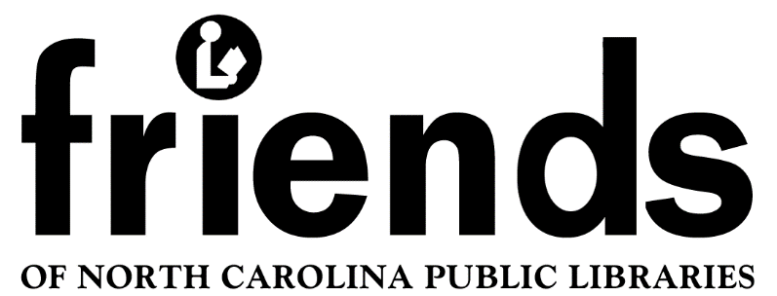

Minutes Board of Directors Meeting

July 10, 2021, 2021 Zoom meeting 10:00 AM
Board Meeting

Attended:
Judy Hills, President
Joanne Straight, Secretary
Mark West, Treasurer
Joyce Speas, Director
Meg Forward, Director
Becky Smith, Director and Membership Chair
Eileen Alexander, Director & Newsletter Chair
Lynda Reynolds, Ad Hoc, State Library Liaison
Kathy Lambe, guest

The meeting was called to order at 10 am via Zoom. A quorum was established.

Mark moved to accept the minutes of the March 14th and April 10th meeting, seconded by Eileen, and approved by all.

4. Treasurer’s Report Mark emailed the Treasurer’s report which was accepted as presented.

5. Status of Board Judy reminded Board members that there are still two vacancies: vice-president and one director.
Judy also provided some background on Kathy Lambe, a potential board member, who is a library trustee for the Winston-Salem Forsyth County Library, a Friends member in two groups and the daughter of a librarian.
Please forward names of any interested nominees to Judy.

6. Reports
a. Membership - Becky provided updated membership numbers. There are 4 new group members and 6 new individual members. Mark commented that there is still a $20 difference in the membership revenue in his report in comparison to Becky’s. He thinks that it should be simple to find the discrepancy.
b. Newsletter - Eileen hopes to get the newsletter out in the next week to ten days, She needs content (contributions from Friends groups & other sources to create a newsletter. Eileen currently checks some of the larger Friends groups websites for updates that can be published.
c. Awards & Grants - Eileen will include information about the new awards in the upcoming newsletter. Judy will send information on seed grants for new or revitalizing Friends groups to the NCPLDA.
d. Website - Mark has been struggling to get a new website set up on WordPress. He is creating a new domain name FONCPL.info Mark proposed that we contract for space on Go Daddy which will provide both hosting and the WordPress website. Mark has already created the template. His recommendation is to contract with GoDaddy at $300 for three years. Joyce moved to accept this proposal, Joyce seconded the motion and it carried unanimously.
Mark announced that there have been three dozen additional views of the virtual spring workshop sessions since our April meeting.
e. Lynda Reynolds, the State Library Liaison urged members to contact their Senators and local representatives in support of the Build America’s Libraries Act. The Act will bring money to every state to build or renovate libraries in underserved communities.
Mark commented that from his experience as a Library Director working with Congressional Representatives it is more effective to send a personal message. They will ignore anything that is mass-generated.
Judy requested that Joanne, as Secretary, draft a letter stating our support for this act as library volunteers.

7. Old Business
a. Charitable Solicitation License - Mark will get together with Judy and Joanne to get this taken care of soon.
b. Review of 2020 Financial Records - Mark will mail the financial records to former FONCPL Treasurer Bill Oelkers. He and Mark will review each other’s work on the financial records.
Judy reminded everyone that is a good practice for all groups to get a third party to review their financials.
c. FOL Listserv Update - Lynda reported that currently there are just 27 members on the Listserv so there is not much action. Judy asked Joanne to make up a schedule for all the directors to take turns posting to the listserv every two weeks. Posts can be questions, comments or best practices but hopefully will promote more interest in the listserv.
d. Contacting Existing Friends groups - Judy wants to continue contacting existing Friends groups to update their contact information and encourage FONCPL membership in those groups that do not belong.

8. New Business
a. Judy presented a proposed calendar for the remainder of the year.
b. Fall virtual workshops - Judy prepared a suggested list of topics and presenters for the fall workshops. The presentations should be 15-20 minutes in length. Mark was great about helping the presenters for the spring virtual workshops. Mark suggested that the PowerPoint presentations were the most interesting, particularly with Picture in Picture of the presenters although the most viewed was a “talking head” video. The topics seemed to be more important than the method of presentation.
c. Annual Meeting - Mark’s term is up but he is eligible for two more two-year terms in the position. Joyce Speas and Trudee Farley can be reappointed. They are each eligible for two more two-year terms as Directors.

9. Comments. Suggestions, concerns - Lynda asked about the September 18th West Central Workshop at Gaston County Library. Judy explained that it is being planned by Linda Klocker with the Gaston County Friends. It is not organized by FONCPL. Mark recommended that we tell the organizer to drop “West Central” from the workshop title since that is associated with FONCPL regions. We want to make sure that attendees and organizers realize it is not FONCPL organized to avoid potential liability.
Judy will ask the organizer to remove the region designation. Becky and Eileen will be attending the Gaston County Friends and report back.
Mark suggested that in person programs be planned for 2022. Judy wants to continue with a virtual format since it eliminates the need for travel and can be viewed any time. It was agreed that this year’s annual meeting on December 4th will be virtual. All members will be notified and invited to attend.

The meeting adjourned at 11:05 am.

Follow Up:

Judy will contact Kathy Lambe to see if she wants to join the Board.
Judy will send a letter to the NCPLDA with information about the Seed grant opportunity for new Friends groups or activating a defunct group. DONE

Mark will contract with GoDaddy for a three-year contract for a new domain name and website hosting. He will continue developing the new site using WordPress.

Joanne will draft a letter of support for the Build America’s Libraries Act on behalf of FONCPL Directors.

Mark will get together with Judy and Joanne to complete the application for a Charitable Solicitation License.
Mark will mail the financial records to former FONCPL Treasurer Bill Oelkers for review. Mark will review Bill’s portion of the records.

Joanne will make a schedule for the directors to post on the state’s FONCPL listserv every two weeks - questions, comments, best practices.

Judy is looking for suggested topics and/or presenters for the fall workshops. Please let her know if you have any suggestions.
Judy will notify Linda Klocker, who is planning in person workshop in Gaston County on September 18th.The regional designation should be removed from the description since FONCPL is not sponsoring the workshop. DONE

