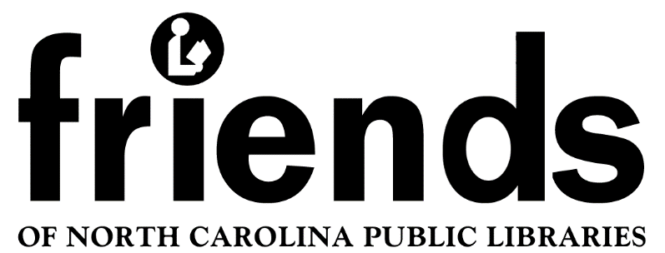

Minutes Board of Directors Meeting

February 6, 2021 Zoom meeting 10:00 AM
Board Meeting

Present:
Judy Hills, President
Mark West, Treasurer
Joanne Straight, Secretary
Joyce Speas, Director
Donna Morgan, Director
Meg Forward, Director
Eileen Alexander, Director
Becky Smith, Director
Lynda Reynolds, Ex Officio, State Library Liaison

- Call to order by President Hills at 10 AM.

- Established a Quorum

- The minutes of the 8/15/20 and 12/15/20 were approved as presented on a motion by Becky Smith, seconded by Mark West. There are no minutes to approve for the discussion held on 10/03/20.

- Treasurer’s Report - Mark reported that the 2020 annual report is now available on the website and includes the financial report for the year. January’s financial activity included the payment of dues to United for Libraries and the receipt of $1520 in membership dues for 2021.

- Status of Board - Judy reported that she has a potential candidate for Vice President and leads on potential Directors to fill the two vacant positions. Please forward any vacant Board positions to Judy.

- Reports
- Membership - Becky emailed a reminder renewal notice to all individual and group members. Renewal forms are available on the website. So far, 23 groups have submitted dues including 2 new groups. We have also received dues from 40 individual members, including 3 new individuals. A reminder notice was included in the January edition of the newsletter. A second email reminder will be sent out at the end of February to both groups and individuals who have not renewed. Mark will provide Becky with an updated list of lapsed members for this mailing.
The virtual workshop notices sent out in March will also include a membership reminder.

- Newsletter - Eileen reported that she received positive feedback on the January newsletter. The March newsletter will focus on the virtual workshops in April and information from the Board’s March meeting.

- Awards Committee - Chairman Donna suggested that the annual awards include one group award for the entire state and an individual award for each of the five areas in the state. All award recipients will be acknowledged with a certificate.

Donna asked if the awards should continue to be named in honor of long time FONCPL supporters. It was decided to keep the individual award as the Frannie Ashburn Award. The group award will be named the Frances B. Reed Group award.

Donna explained the new grant proposals for Friends groups. There would be two grants- one for new or revitalizing groups and the other for groups that need financial assistance for projects or events. The grant for new or revitalizing Friends groups will be called a Seed Grant. Mark suggested that the amount for this grant be $500 and that we offer three of these in 2021. Becky moved and Mark seconded this proposal which passed unanimously, Applications for this grant will be accepted throughout the year,

The group grant, to be called a Challenge Grant, will have an application deadline of September 15th each year with the award to be presented at the annual meeting each fall. This grant will award a maximum of $250. The number of grants to be awarded each year will be determined by the available funds. We decided that Challenge Grant applicants would need to contribute to the proposed project or program. Mark moved and Joyce seconded this proposal which passed unanimously.

This year we will fund up to three Seed Grants and two Challenge Grants (total of $2,000 maximum). The March newsletter will have an article on these new grants. The applications will be available on the FONCPL website.
- Old Business
- Charitable Solicitation License. This will be taken care of shortly by Mark in coordination with Judy and Joanne.
- April Workshops - Mark set up a You Tube Channel which will be used for virtual webinar sessions. These videos will be posted on our website and can later be used by individual Friends groups as training or meeting programs. Mark suggested that Judy and Joanne introduce the segments.

- New Business -
- Annual Report. Judy reported that the 2020 Annual Report is posted on our website and its availability was noted in our recent newsletter.
- Mark recommended that the line item for grants in the proposed 2021-2022 budget be increased to $2,000. Donna moved to accept the proposed budget with the addition of Mark’s recommendation, seconded by Eileen and the motion carried.
- Lynda Reynolds stated that the State Library has migrated to new Listserv software. She said that would be possible to start a new Listserv for all the Friends groups in NC. Lynda would be the moderator and created a suggested Code of Conduct based on similar codes. There was general consensus among the Board members that they are interested and think it will be beneficial.
- Judy announced that she is working with the state Friends of Public Libraries in Georgia, Tennessee, and South Carolina in requesting that United for Libraries update their MOU fact sheet.

- Next Zoom meeting- March 13, 2021 at 10 AM

- Adjourned at 11:14 AM

Follow Up:
- Mark will provide an updated list of lapsed members to Becky in late October.
- Becky will send a reminder email to renew membership to lapsed members in late February.
- Donna will work with Mark to revise wording on the information sheet for Seed
Grants.
- Judy will revise the Seed Grant and Challenge Grant information sheets and application forms to reflect what was decided today. She will send them out to members to review (DONE)
- Lynda will email out the code of conduct proposed for the Listserv. (DONE)
- Eileen will include information on the grants and April workshops in the March newsletter.

