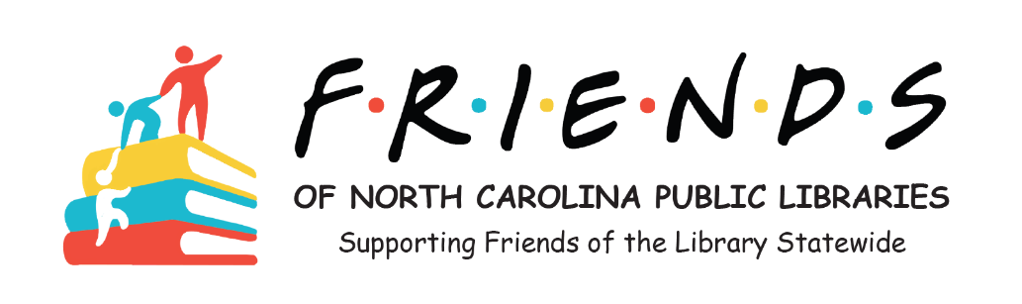
Minutes of December 17, 2024 Email Vote
The Board of the Friends of North Carolina Public Libraries unanimously voted by email to elect Joyce Speas to serve a one-year term as President for 2025.
Respectfully submitted,

Joanne Straight
Secretary

